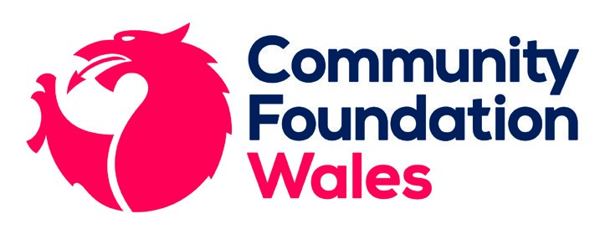
Fund Criteria:
Trivallis Community Investment Fund
Trivallis Community Investment Fund, managed and promoted by Community Foundation Wales, is designed for constituted community groups and voluntary organisations supporting people within the Trivallis communities. Successful applicants will strongly demonstrate the positive impact/s they will have on the people living there.
Projects must meet at least one of the following themes:
- Social inclusion
- Health and wellbeing
- Learning and Employability
- Sustainable environmental improvements

There are two streams of funding: Fast Track Applications and Large Grant Applications. You can find more information about these two different streams in the section below.

Grants Available
This Fund is open to constituted community-based charities and organisations (e.g. associations, social enterprises and clubs). Groups can receive up to £6,000 in any one year i.e. one small grant (fast track application) and one large grant.

Fast track applications under £1,000 should be submitted along with all supporting documents. We aim for fast-rack applicants to hear notification of decision within two weeks of submitting an application.

Large grant applications from £1,001 to £5,000 will go to a different panel, and therefore have a target turnaround time of 8 weeks. We encourage all applicants to schedule a conversation with a Grant Officer about their project prior to submitting an application to ensure their eligibility. Applicants can schedule a conversation with a Grants Officer to discuss their project idea and check for eligibility through our website before applying, if they would like to.

Preference will be given to:
- Applicants who can demonstrate exactly how they will meet the Fund’s objectives and priorities
- Applications from groups/charities/organisations that are wholly based in the Rhondda Cynon Taff valleys, and whose beneficiaries are also all in this area
Who can apply:
- New or established groups across Rhondda Cynon Taf
- Constituted groups
- Groups that involve and include Trivallis tenants
- Projects that meet at least one of the Trivallis funding themes
- Applications from National charities or other organisations not based in RCT, who wish to apply for a project that will be based in the RCT area, will also be considered but not prioritised.

We cannot fund:
Contact us on
02920 379 580

or email
grants@communityfoundationwales.org.uk
for more information
- Individuals or Sole Traders
Fund Criteria:
Trivallis Community Investment Fund
- Private companies
- Statutory bodies
- ‘Friends of’ groups, which support a statutory provision or responsibility
- Organisations not based wholly in the UK
- Professional fundraisers
- Groups promoting political or religious belief
- Core costs
- Part-fund salaries (this does not include sessional workers, which can be funded)
- Any group that has received funding from the Trivallis Community Investment Fund in the last financial year (April 2021 – March 2022)

How to apply?
Applicants must complete an online application form, which can be accessed via our website.
Please note:
- You must upload your governing documents, most recent accounts, and your updated safeguarding policy
- Grants will not be awarded retrospectively i.e. for costs incurred before receipt of our grant offer letter, and the signed terms and conditions have been returned
- Grants are not available towards general fundraising or to support fundraising for other groups and charities
- Grants must be fully spent within one year of receipt of our offer letter
- You cannot reapply for 12 months after being awarded a Fast Track or Large Grant from this fund

